ECE 416

Fall 2016

Simulation 1

Youthawin Philavastvanid

Matlab:

Question 1 A:

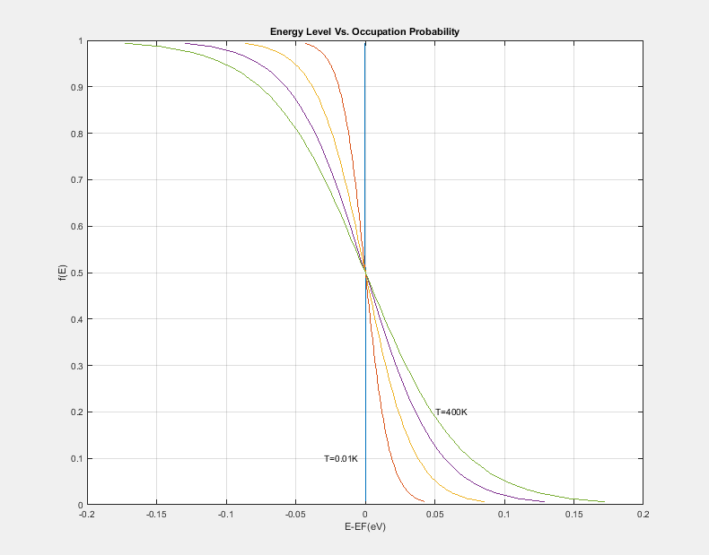

Temperature (K) plots on energy level(eV) Vs. electron occupation probability on a silicon at 0.01K, 100K, 200K, 300K, 400K.

Interpretation

The goal for this section of simulation is to explore the relationship between temperature and electron occupation probability which describes by



The equation above is also known as Fermi Function. The function signifies the probability of a state at an energy E will be occupied by an electron. The function implies an energy level which dividing between almost-full and almost-empty states.

On the other words, at T=0K, the graph can be interpreted as all states at energies below a fermi-energy will be filled and all states at energies above a fermi-energy will be empty. In the range of E­F ± 3kT, the filling pattern changes less drastically providing a range of energy which a state can be almost-empty and almost-filled.

Question 1 B:

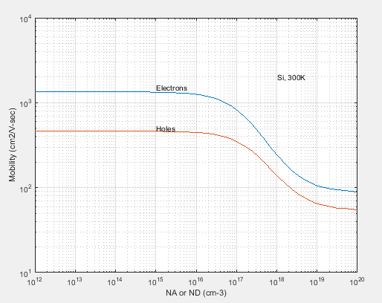

The empirical-fit plots of holes and electron mobility.



Interpretation

Mobility is a measure how easy for a carrier to move within a crystal. A mobility is low when there is a lot of motion impeding collisions within a crystal. Generally, there are two major motion impeding mechanisms: lattice scattering, and ionized impurity scattering. The plot shows carrier mobility in response to ionized impurity scattering -- the lattice scattering is negligible in a high temperature (300 K) with high dopant concentrations. The empirical-fit for hole and electron mobility is given to us in assignment description as the following:



Where Nx is doping concentration.

Note that the modeling function is only depending on concentration of dopants and does NOT depend on the temperature or dopant element --- it only depends on holes/electrons of the dopants, not the element itself.

The plot shows the decrease in mobility of both holes and electrons as the concentration of dopants increases. It is because the crystal lattice becomes very crowded making it very difficult for a charge carrier to move around without colliding into other mass, decreases in speed. Thus, the mobility is decreased.

Question 1 C:

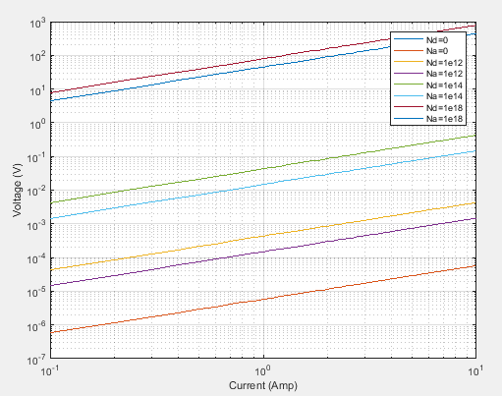

A plot of voltage(V) vs current(A) of different silicon dopant impurities(cm-3).

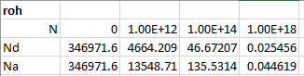

Interpretation

A resistivity or conductivity of a semiconductor is directly correlated to the material mobility. As we recall from part 1(b) that too much dopant concentration can hinder a charge carrier mobility. An electrical current which relies on a charge carrier mobility is also impacted. The relationship between charge carrier’s mobility and its resistivity can be mathematically represented by



Hence we know the resistivity of a material, we can find a resistance of a piece of silicon using Pouillet’s law:



It can be observed that as mobility decreases, due to impurity scattering, the resistivity of the silicon should be increased. To prove this hypothesis, we do a plot Voltage Vs. Current of different silicon dopant concentration.

Given ohm’s law:



We are able to find the resistivity of a silicon at a differ dopant concentration by measuring the slop of the V-I plot.

As we expected, the higher the dopant concentration, the lower the mobility of charge carrier, the lower the conductivity of the silicon chunk.

ATLAS:

Recall the information from Matlab section 1(b) and 1(c) that

* The charge carrier mobility is only depending on concentration of dopants and does not depend on the temperature or dopant element
* A resistivity or conductivity of a semiconductor is directly correlated to the material mobility.
* A resistivity of a material can be measured using the slope of a V-I graph. (Ohm’s law)

A series of experiments were conducted using “deckbuild” to confirm the hypothesis. We run experiments with different dopants concentration (N­­A = 1018 cm­-3; ND = 1018 cm­-3 ; and N­­A = 1018 cm­-3; ND = 1.7x1018 cm­-3  ) with different type of dopants (Si, Ge, InAs)

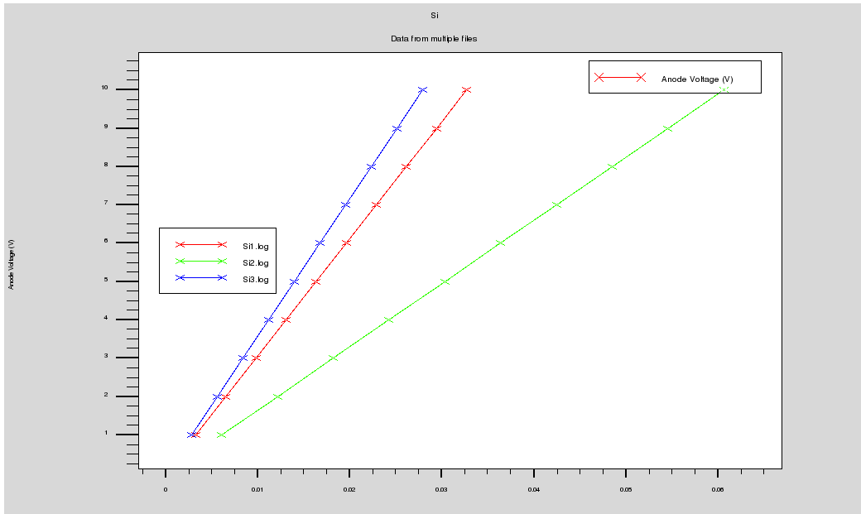

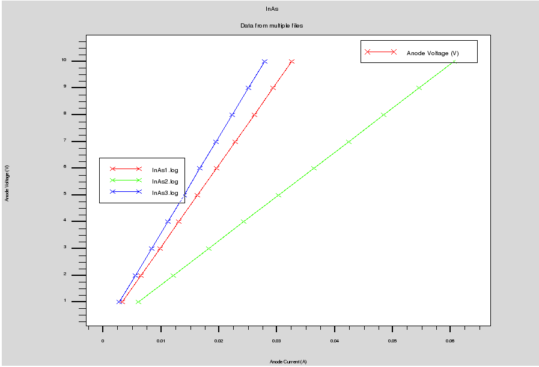

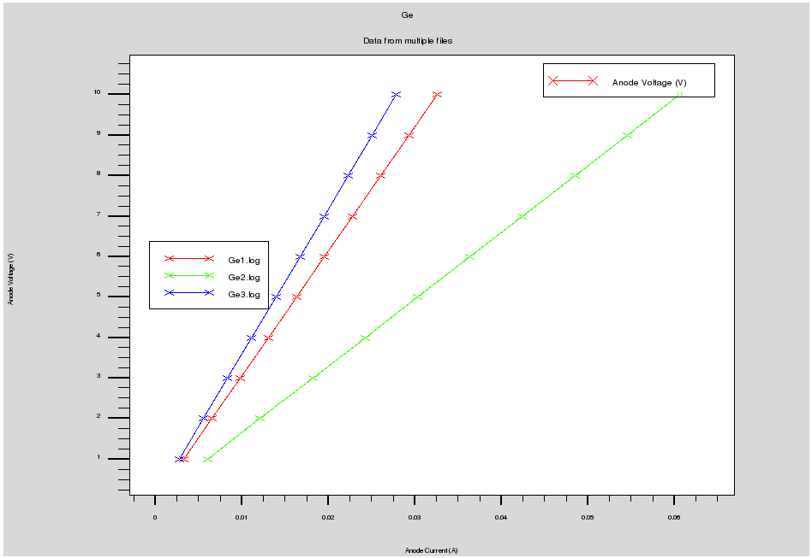

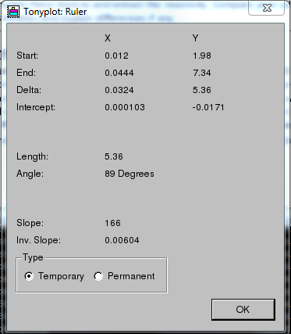 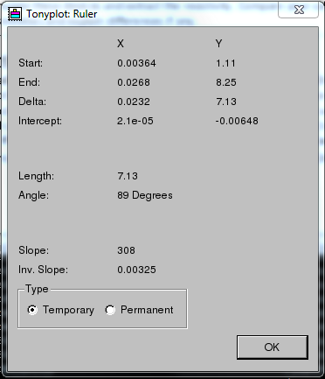 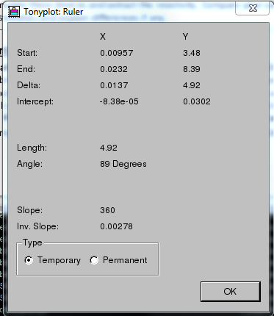

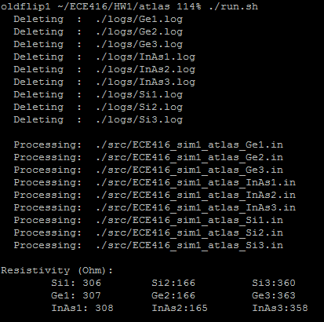

By looking at the V-I plots, we notice two prominent features across all three graphs:

1. There are three lines on each plot, each line represents a different dopant concentration.
2. Each of the dopant concentration line has the same slope across all three graphs.
3. The last mixed N­­A = 1018 cm­-3; ND = 1.7x1018 cm­-3 has a much lesser slope than the first two dopant concentrations.

First, each dopant concentration has its own slope, it implies that the resistivity of a material is depending on the dopant concentration.

Second, at the same dopant concentration, the three graphs produce the exact same slope plot which implies that the same resistivity across all the materials. We can safely verify that the resistivity and mobility of a semiconductor does not depend on the element used in as a dopant – only the type of material that is matter (N-type or P-type).

Third, the case of N­­A = 1018 cm­-3; ND = 1.7x1018 cm­-3 has a lower slope, a lower resistivity, than the first two dopant concentration even though, there are more material added to it. The phenomenon is known as “counter doping” meaning the two added dopant cancelled each other out producing a much less affect in dopant impurity.

Appendix: (Please see tar.bz2 file)